**DAILY ONLINE ACTIVITIES SUMMARY**

|  |  |  |  |  |  |  |  |
| --- | --- | --- | --- | --- | --- | --- | --- |
| **Date:** | **07-06-2020** | | | | **Name:** | **K Manasa** | |
| **Sem & Sec** | **8th ''** | | | | **USN:** | **4AL16CS043** | |
| **Online Test Summary** | | | | | | | |
| **Subject** | | **-** | | | | | |
| **Max. Marks** | | **-** | | **Score** | | **-** | |
| **Certification Course Summary** | | | | | | | |
| **Course** | **Python for machine learning** | | | | | | |
| **Certificate Provider** | | | **Great learning** | **Duration** | | | **3hr** |
| **Coding Challenges** | | | | | | | |
| **Problem Statement:Not given** | | | | | | | |
| **Status:Solved** | | | | | | | |
| **Uploaded the report in Github** | | | | **Yes** | | | |
| **If yes Repository name** | | | | **Manasa** | | | |
| **Uploaded the report in slack** | | | | **Yes** | | | |

Certification Course Details: (Attach the snapshot and briefly write the report for the same)

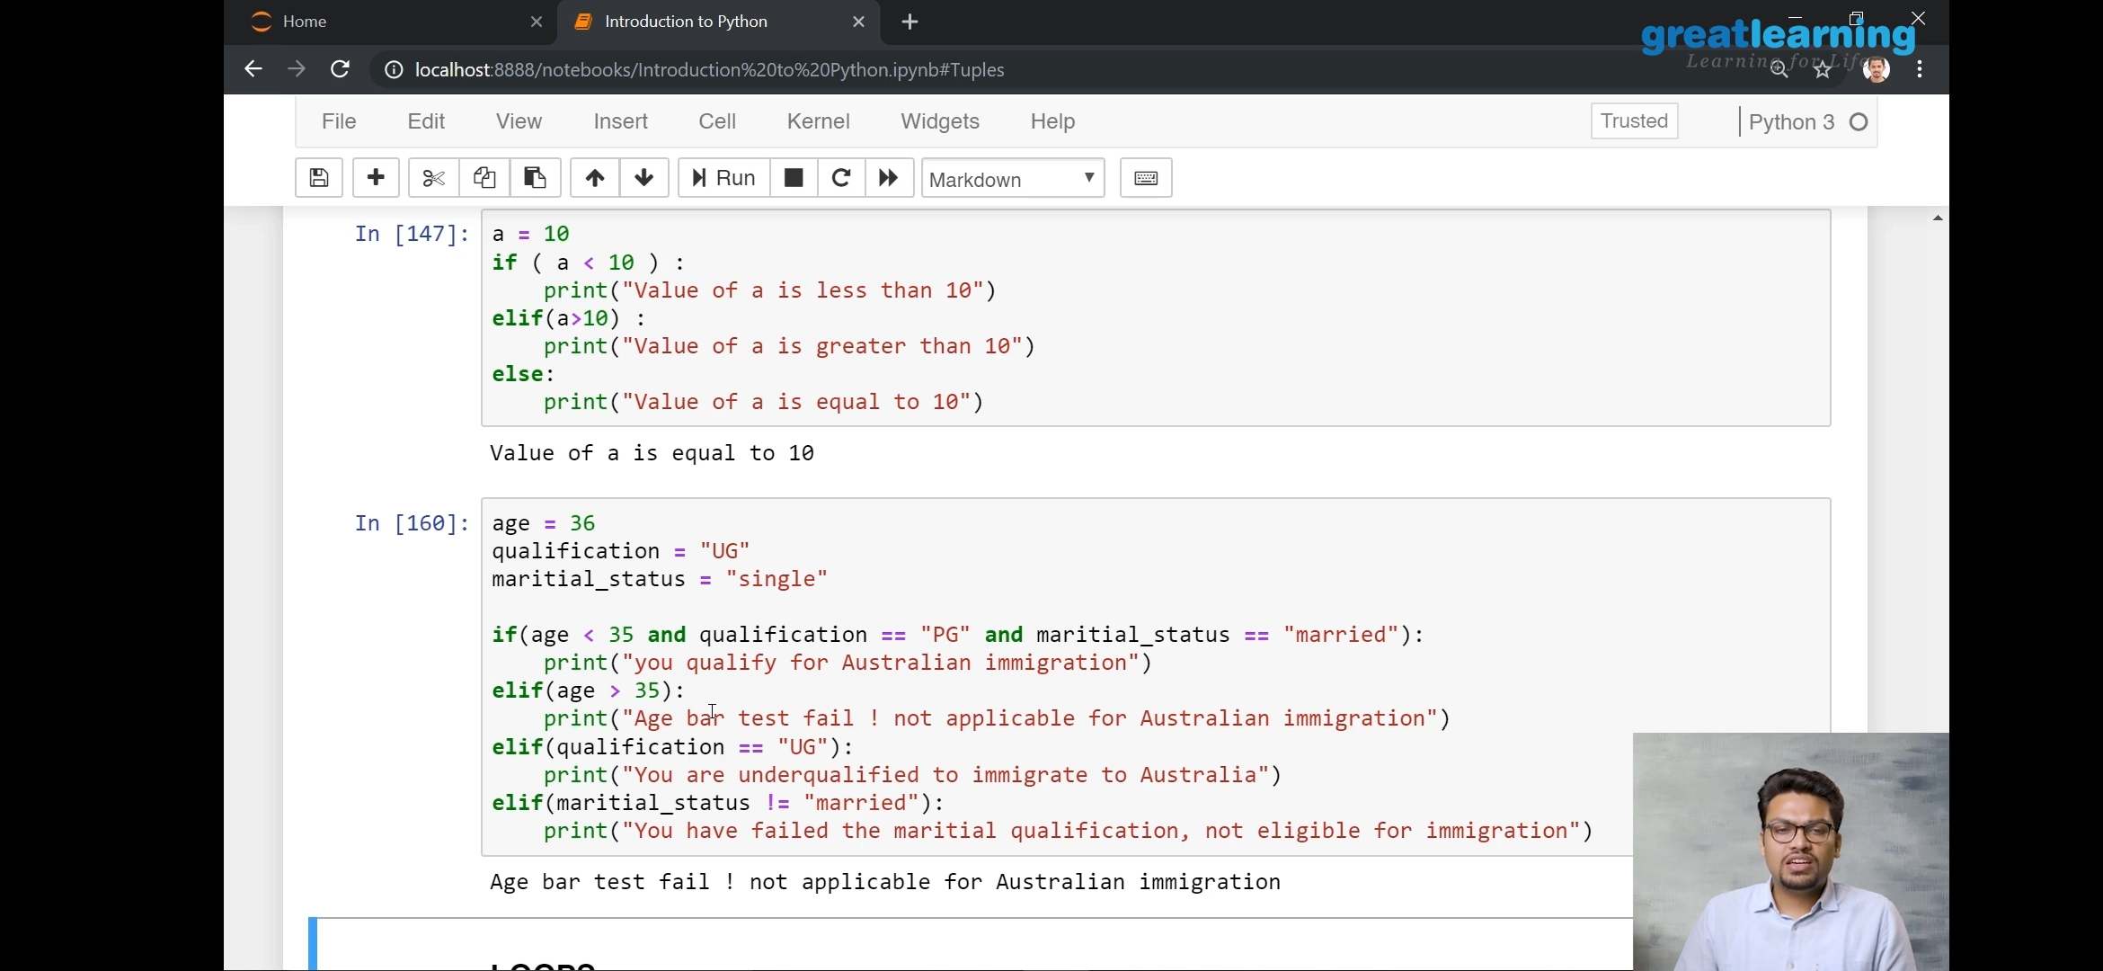

Coding

PROGRAM1

def binary_search(item_list,item):

first = 0

last = len(item_list)-1

found = False

while( first<=last and not found):

mid = (first + last)//2

if item_list[mid] == item :

found = True

else:

if item < item_list[mid]:

last = mid - 1

else:

first = mid + 1

return found

list1 = [int(item) for item in input("Enter the number to perform binary search : ").split()]

print(binary_search(list1,len(list1))